IHE Profile Proposal (Short)

Proposed Profile: Chronic Care Coordination/Community Referral Workflow
Proposal Editor: Jon Hilton (jon.hilton@precedencehealthcare.com), Health Informatics Society of Australia (HISA)
Chris Lindop (Christopher.lindop@ge.com), GEHC
Vincent McCauley (vincem@mccauleysoftware.com), Medical Software Industry Association (MSIA)
Jane Gilbert, (j.gilbert@ballarat.edu.au), Convener, IHE Australia eReferral Task Force
Max Walker, (Max.Walker@dhs.vic.gov.au), Department of Health, Victoria
Klaus Veil Klaus@Veil.net.au, HL7 - Australia

Date: September 10 2009
Version: 0.1
Domain: Patient Care Coordination

The Clinical Problem
An increasing number of people are suffering and dying needlessly from diseases such as obesity, diabetes, heart disease and asthma. Five chronic diseases—heart disease, cancer, stroke, chronic obstructive pulmonary disease, and diabetes—are responsible for the majority of deaths by disease worldwide. In addition to the tremendous human cost, chronic diseases exact an enormous financial toll on health care resources and strain public health departments and finances.
The effective treatment of chronic illness is characterized by productive interactions among involved patients, their carers, and a prepared team of healthcare providers. The Wagner Chronic Care Model is now widely viewed as providing a comprehensive best-practice model for this type of care. The goal of the model is to deliver care that is safe, effective, timely, patient-centered, efficient and equitable.
At the level of clinical practice, four components of the Wagner Chronic Care Model influence the ability to deliver effective chronic illness care. These are: self-management support; delivery system design; decision support; and clinical information systems.
Although the Wagner Model focuses specifically on Chronic Care, the principles of collaborative Chronic Care Coordination/Community Referral Workflow should be equally applicable in supporting planned transition between different areas of health care, such as acute to primary care, aged care to acute, etc.

Key Use Cases

Diabetes Care Coordination
Bob Glucose, a patient, is diagnosed with type II diabetes by his doctor, Dr. Planner. Dr. Planner creates a care plan in consultation with Bob, using current best practice guidelines such as Map of Medicine.
The content of the care plan includes a schedule of tasks that are to be performed by the patient, by the doctor and by other health care providers (the care team.) In Bob’s case the care team consists of a diabetes educator, a podiatrist, an optician, a pharmacist and a psychologist. Encounters with the care team are scheduled in the plan with indicated dates. Dr Planner lodges a copy of the care plan in a shared repository and creates electronic referrals to the care team including a reference to the care plan. Dr. Planner gives Bob a copy of the care plan and asks him to make appointments with the providers identified in the plan.
Each member of the care team, on receiving the referral, acknowledges receipt of the referral. When Bob arranges an appointment, each member lodges a referral record in a shared repository identifying the appointment date. As Bob visits the care team members, each member lodges a record of encounter including any reports relating to the encounter in the shared repository.
Six months later, Bob visits Dr. Planner for a regular review. Dr. Planner is able to access the shared repository and can see reports from the podiatrist and diabetes educator, but notes that there is no record of encounter with the optician. Dr. Planner counsels Bob on the risks of retinopathy and advises him to visit the optician for a check as soon as possible.

Standards & Systems Currently Available
IHE XDS, XDS-MS, IHE PCC Content Profiles
HL7 REF

Other Discussion
This profile is intended to build on referral profiles/standards that already exist. The profile should reference or include other profiles relating to pathology, radiology and other clinically relevant data.
It is important to recognize the power of aggregating simple (trivial seeming) process data to support coordination of care. The evidence is that planned care is successful only if the plans are followed. Further, there is evidence that monitoring and following up improves compliance.
A key feature is the recognition that referral implies follow-up, that coordination is best supported by providing access to information, and that an XDS repository is a good mechanism for supporting this.
While the use case example involves a GP (family physician) as the care coordinator. It is possible for other actors to take this role and the final profile should recognize this.
For simplicity the use case example ignores possible branch points and sub-processes. Attached is a flow diagram that captures detail of the referral process in community care.
In words, some of the possible processes are:
Referral rejected by care team member. Care team member may not have capacity, patient may not be eligible for service, etc. Another care team member should be selected to replace them, new referral generated and patient notified of change
Referral unable to be completed – patient initiated. Waiting list may be too long, patient may decide that the referral is inappropriate, etc. GP should be notified, new referral generated and patient notified.
Prior to referring the patient, or if a referral is rejected/ unable to complete, then GP may need to identify qualified providers and resources which can meet the schedules or unique needs of the patient. The workflow can be augmented to include a query to a services and provider registry to identify possible alternate providers that could provide the services necessary for the health and well being of the patient.
The outlined approach should support where possible automated submission of data integrated with existing IHE content profiles as well as existing departmental and enterprise workflows. For example, a billing event is a good indicator that an encounter took place, and will typically identify clinically relevant information, the time and location of the encounter. In this example, lodging a summary that excludes financial details in an XDS repository would be useful in supporting coordination of care.
Note that this proposal is supported by the IHE Australia Deployment Committee. The proposal does address the needs of this region. Many regions internationally, including Canada have expressed similar needs and should be involved in the collaboration of this profile development.
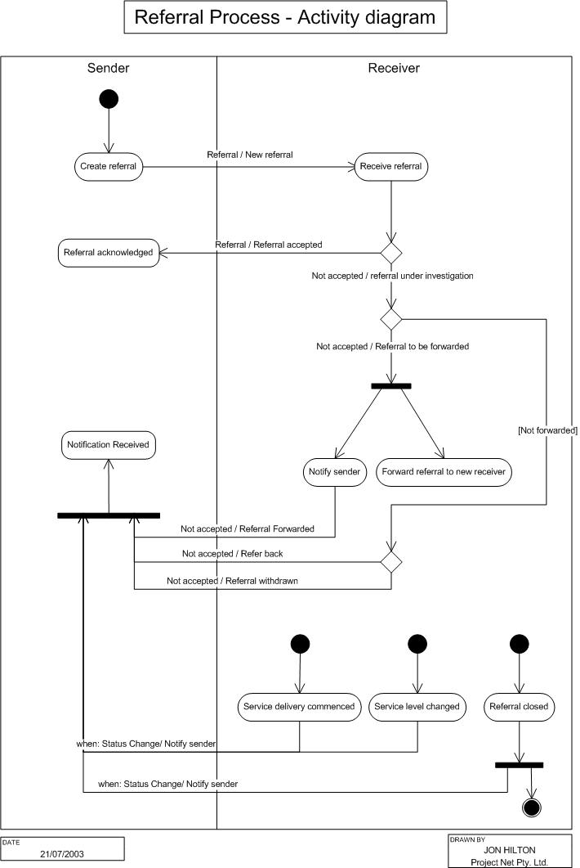

Wagner E, Austin B, Von Korff M. Organizing care for patients with chronic illness. Millbank Q 1996: 511-544.

